Shri Vadnagara Nagar Mandal, Mumbai – Vishishtha Paritoshik Nominations

Shri Vadnagara Nagar Mandal, Mumbai hereby request Members to nominate Vadnagara Nagars who have achieved success in various fields like Arts, Business, Medicine, Education, Charity etc. Every year, we make a point to felicitate these Successful Vadnagara Nagars who can inspire others through their achievements. If you know someone like that, please go ahead and fill up the nomination form and let us know their details. These nominations received from website will be scrutinized by our Committee and we will select the deserving personalities to be felicitated, keeping various criterias in mind. Please note that the Decision taken by Committee for the Selection of the dignitaries from nominations received will be final. No other correspondence regards the same except Nomination will be accepted.

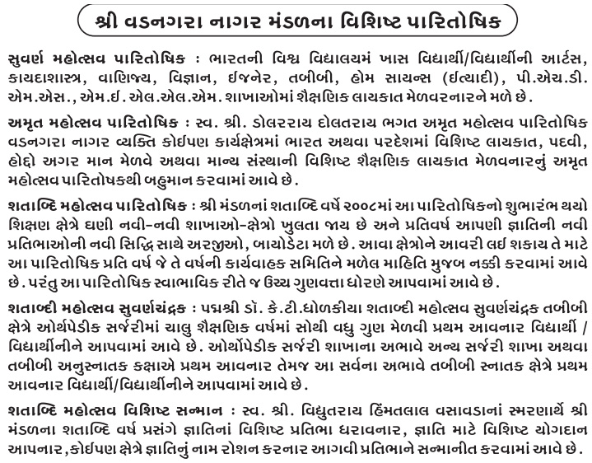

Last Date for Nominations: 15’th December 2019.
Please download the nomination form and fill up the details and send the same on apps@shrivadnagaranagar.org

